Lab 35-1 | Testing a Siebel Workflow Process
Objective: To simulate a workflow process to determine that the workflow executes as designed. |  |  25-35 minutes

Instructions:

- If necessary, start Siebel Tools and log in as SADMIN/SADMIN connecting to the Sample Database.

- You will first make sure that the Debug options are set to allow the Workflow Simulator to run correctly.
  - In Siebel Tools, select View > Options.
  - Click the Debug tab.
  - Make sure the following run-time startup information is entered.

Executable | D:\Siebel 8\client\BIN\siebel.exe
CFG File | D:\Siebel 8\client\BIN\ENU\uagent.cfg
Browser | C:\Program Files\Internet Explorer\iexplore.exe
Working Directory | D:\Siebel 8\client\BIN\
Arguments | /h

  - Make sure the following login information is entered.

User name | SADMIN
Pass word | SADMIN
Datasource | Sample

  - Click OK.

- If necessary, expose the Simulation toolbar by selecting View > Toolbars > Simulate.

- In order to simulate the Sample Account URL Creator workflow you created in the previous lab, you will need to first create a test contact record in the Siebel application.
  - If necessary, double-click on the Siebel Call Center shortcut on the desktop. Login as SADMIN/SADMIN connecting to Sample database.
  - Navigate to the My Accounts View.
  - Create a new record with
Account Name | Sample Account

  - Drill down on the new record and click the More Info tab.
  - Verify that the URL field is blank. This is the field into which the workflow process inserts the contact identifier.
  - Come back to the Accounts list by clicking on Accounts List in the link bar.
  - Right-click the Sample Account record and select About Record. Record the row number. ____________
  - Click OK.
  - Log out of the Siebel Call Center.

- You will now invoke the Workflow Simulator to test the workflow process. The simulator can be invoked from either the workflow process list in the object list editor or directly from the workflow designer.
  - Return to Siebel Tools and display the workflow designer with the Sample Account URL Creator workflow process.
  - Click the Process Properties tab on the MVPW.

  - Select the Object Id process property.
  - Locate the Default String property and enter the row number for the account record you just created. You may have to scroll to the right to display the Default String property.
  - Save the new data by clicking the Save button in the toolbar. Configuration data in the workflow designer must be saved explicitly.
  - Right-click in the workflow designer and select Simulate. Observe that a new tabbed window appears in the editor with the first step of the workflow outlined. Also note that the first button in the Simulator toolbar is highlighted.

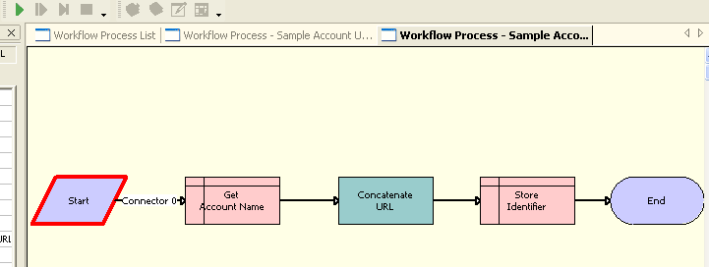

  - Click the (green) Start Simulation button in the Simulate toolbar. Observe that an instance of the Siebel client starts, and that it takes several seconds for the client to display a view titled Workflow Simulator.
  - Once that view appears return to Siebel Tools, and wait until the initiation of the simulation has completed. You should see the second step in the workflow process highlighted.
  - Right-click in the simulator window and select Watch Window to open the watch window. If necessary expand PS: Property Set to display the properties in the watch window.

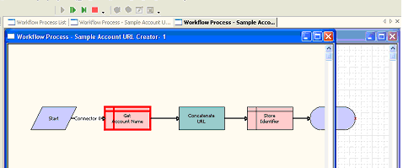

  - Click the Simulate Next button in the Simulation toolbar to execute the step that is highlighted. Observe the Account Name process properties in the Watch window display the fields from the Account record you created. If necessary expand Workflow Process Data to display the properties in the watch window. If this step errors out, you should stop the simulation and verify that the search specification was entered correctly.

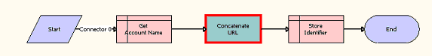

  - Click the Simulate Next button until the End step is highlighted. After each step inspect the process properties using the watch window to verify that the process properties are populated as desired.
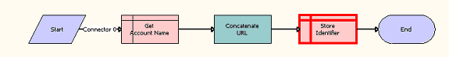
  - Click the Simulate Next button once more to complete the simulation.
  - Click OK and then close the Simulator window.
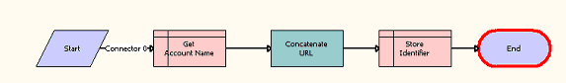

- You will now verify that the workflow did store the Account URL.
  - Return to the Siebel Call Center application.
  - Navigate to the Sample Account record you created. A direct way to do so is to navigate to the Accounts Home screen and click the link under recent records.
  - Navigate to the More Info view.
  - Verify that the URL field now displays the contact identifier created by the workflow.

- Once you have completed simulation of the workflow process, you should delete the row number for the context record you created.
  - In Siebel Tools, return to the workflow designer.
  - In the Process Properties tab in the MVPW, clear the Default String property for the Object Id process property.
  - Make sure to explicitly save these changes.

- The workflow is now ready to be deployed to the client for further testing.
  - Click the Workflow Process List tab in the OBLE.
  - Select the Sample Account URL Creator record.
c. Click the Publish button in the WF/Task Editor Toolbar.
- Verify that the workflow process was deployed by checking the status set to Completed.

- You will finally activate the workflow process in the client.
  - In Siebel Call Center, navigate to Administration - Business Process > Workflow Deployment.
  - Select Sample Account URL Creator in the Repository Workflow Processes list applet and click Activate.
  - Verify that the workflow appears in the Active Workflow Processes tab in the lower applet. The workflow is now ready to be tested in the client.

Lab 35-2 | Testing Branching in a Siebel Workflow Process
Objective: To simulate a workflow process that involves branching. |  |  25-35 minutes

Instructions:
In this lab, you will simulate the Sample Secure Opportunity workflow process you created in a previous lab. The workflow includes conditional processing and you will run the simulator two times to verify that the workflow executes the conditional processing correctly.

The instructions in this lab are not as detailed as in the previous lab. Feel free to refer to those instructions when you might need additional details.

- You will first create a test opportunity record.
  - In Siebel Call Center, navigate to Opportunities > Opportunities List.
  - Create a new record with:

Opportunity Name | Sample Opp
Probability | 50%

  - Save the new record.
  - Right-click the record, select About Record, and record the row number. ______________
  - Log out of Siebel Call Center. There must be no running instances of the Siebel client for the simulator to start.

- You will now add the row number as the default value for the Object Id process property.
  - Return to Siebel Tools and display the workflow designer with the Sample Secure Opportunity workflow process, by right-clicking and selecting Edit Workflow Process.
  - Click the Process Properties tab on the MVPW.
  - Select the Object Id process property.
  - Locate the Default String property and enter the row number for the contact record you just created. You may have to scroll to the right to display the Default String property.
  - Save the new data.

- You will next simulate the workflow to verify that it executes the desired conditional logic.
  - Start the simulation following the steps you used in the first part of this lab.
  - Use the Simulate Next button to manually advance the simulation one step at a time.
  - Verify that the workflow executes the Assess Probability step.
  - Complete the simulation, and leave the simulation window open.
  - Return to Siebel Call Center and navigate back to the opportunity record you created.
  - Verify that the flag in Secure check box wasn’t changed.

- You will next modify the Opportunity and observe how the workflow behaves with the data.
  - Modify the opportunity probability as follows:

Opportunity Name | Sample Opp
Probability | 70%

b. Save the record.
c. Log out of Siebel Call Center.

- You will next simulate the workflow to verify that it executes the desired conditional logic.
  - Start the simulation
  - Use the Simulate Next button to manually advance the simulation one step at a time.
  - Verify that the workflow executes the Assess Probability step.
  - Complete the simulation, and leave the simulation window open.
  - Return to Siebel Call Center and navigate back to the Opportunity record you created.
  - Verify that the flag in Secure check box was changed to TRUE now. The check box is set right.

- Once you have completed your simulations, you should delete the row number for the opportunity record you created.
  - Close the Simulation Window.
  - Return to the workflow designer. In the Process Properties tab in the MVPW, clear the Default String property for the Object Id process property.
  - Make sure to save these changes

- The workflow is now ready to be deployed to the client for further testing. This time you will use the Publish/Activate button that publishes the workflow to the client and activates it there as well.
  - Click the Workflow Process List tab in the editor.
  - Select the Sample Secure Opportunity record.
- Click the Publish/Activate button in the WF/Task Editor Toolbar.
- Verify the workflow process was deployed by checking its status. Status should be set to Completed.
- Verify that the workflow process is also activated
i. In Siebel Call Center, navigate to Administration - Business Process > Workflow
Deployment.
ii. Verify that the Sample Secure Opportunity workflow appears in both the Repository
Workflow Processes upper applet and the Active Workflow Processes tab in the lower applet.

